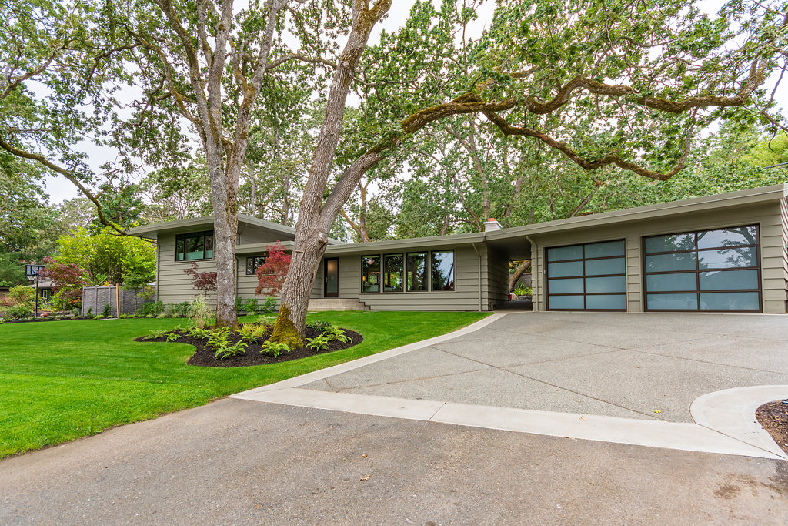
3520 Upper Terrace - State of the Art Security

This residence has a state-of-the-art security system by alarm.com that is currently monitored by Prices Alarms . The system is highly expandable and can operate as a platform for a home automation system or be integrated into others. Selected electrical switches, electrical outlets, thermostats, door bells and other accessories can be integrated into the solution.

alarm.com allows several rules to be created that can be associated with a user code. For instance, if you are out of town and a maintenance person needs access to access the house, you can provide them with a unique code and create rules, such as it is only active from 8:00AM to 10:00 AM and once the code is entered that you receive an alert and the cameras record from the point the system is disarmed until it is armed.

Access to the system can be through the touch screen interfaces, the web, smartphone applications, iPad and Apple TV as well as others. The solution can be integrated with Apple Siri, Google Home and Amazon Echo. One just says, ‘Hey Siri disarm’. For maximum security, the system is set up with your specific voice for these commands to execute.

With geofencing active, the house can arm automatically when you drive away and disarm as you drive into the driveway. Through integration with a home automation system, it is possible for the house to automatically open the garage door as you drive into the driveway, the security system to disarm and various lights within the house to automatically turn on. You can program it do to the reverse when you leave.

Living in one of the safest neighborhoods in Canada, this alarm system is not simply about the physical security of the house but by allowing you to monitor the activities of the house no matter where in the world you are.

The configuration of the current alarm.com implementation is as follows:

- 3 Touch Pad Control Panels located next to the front door, family room back door and in the master bedroom.
- Window & Door Open/Closed Sensors located on all windows and doors that open
- Pet Proof (up to 75 lbs) motion doctors in the living room, staircase, upper hallway, master bedroom, and family room. The placement of the motion detectors enhance the security coverage by covering access points that are not outfitted with Window & Door Open/Close sensors, such as if someone was to attempt entry via a skylight.
- Cameras located in the living room, the staircase and the family room floor positioned to monitor the front/back door as well as the large sliders in the dining and family rooms. Under the current configuration the cameras automatically record in the event that the alarm is tripped. Using the web site or the app, an authorized user can view the cameras real time
- Water sensors located in the utility room next to the water tank and in the basement. In very unlikely event of a water intrusion, either from the internal plumbing system, the sewer system or any other point, the alarm will sound including notification at the central station, alerts sent to your smart device, etc.
- The touch pad control panels are configured to speak and/or make a sound when a door is opened or closed. Numerous configurations are possible including simply nothing happening when these events occur.

Whenever an alarm sounds emails are sent as well as notifications to your smart phone/tablet that allow you to instantly look at the cameras and of course, the central monitoring station will also alert you.

The system uses a highly secure, private, non-visible wireless network to communicate with the associated accessories, communicates via the cell network, thereby ensuring constant monitoring even in the event the traditional ‘land phone lines’ are down, due to a windstorm, etc. It also has extensive battery backup. It will even send you an alert if the power goes out and when it comes back!

Finally, the system can still be armed with certain parts by-passed. For instance, if you have a visitor that awakes early you could bypass the front door, so they will not set off the alarm if they go for a very early walk. Alternatively, you can give them the FOB that they take with them and simply press a button to arm/disarm. When you alarm the system, it will note any items that may need to be bypassed. For instance, if a guest left a window open. You can bypass or go and close the window.

The security system in this house is state of the art and can easily be expanded. Configuration is simple via the web interface or the app. The system provides beyond basic security - you can be alerted when your children come home and disarm, etc. alarm.com provides more than a security system it provides a home monitoring solution.

For more information on this advanced system, visit alarm.com

The alarm monitoring is currently on a month to month basis. Therefore, the new owners can choose to continue with Prices, select another provider or discontinue monitoring.
Requires internet access

